Our goal is to help you to be proficient at implementing the Granite Educational Standards. This guide is intended to help you to start this process and to help you understand expectations for teachers in Granite School District.
Instructional Design starts with Domain 2 – Planning and Preparation. This means understanding and organizing the subject matter for student learning and setting the purpose. The main skills of Domain II are:
- Aligns Instruction with state-adopted standards at the appropriate level of rigor.
- Sequences lessons and concepts to ensure coherence and required prior knowledge.
- Designs instruction for students to achieve mastery.
- Selects appropriate formative assessments to monitor learning.
- Uses diagnostic student data to plan lessons.
- Develops learning experiences that require students to demonstrate a variety of applicable skills and competencies.
You will be very busy as soon as school starts. You need to make a plan and timeline of how you will allocate class time to ensure that students learn the standards for the quarter. By using backward design, you know where your are headed and you can make adjustments to get through essential information before the quarter ends. Where to start:
- Go to the Granite District Curriculum Map and see what standards you are to teach Quarter One. The following web site takes you to the intranet to find each departments curriculum maps.
https://gsdsites.graniteschools.org/departments/instructionalservices/curriculum/socialstudies/Pages/default.aspx
- The lessons you teach will be based on grade-level standards, that are meaningful and relevant beyond the task at hand (e.g., relates to a broader purpose or context such as problem-solving, citizenship, etc.), and helps students learn and apply transferable knowledge and skills. It is measureable with clear criteria for success.

- Go to the USOE Standards that you are to teach for the Utah Core. Get an overview for the year. (They can be found on the curriculum map page for your subject) If not, go to
http://www.schools.utah.gov/CURR/main/Areas-Programs.aspx
- Look at the Instructional Support Materials for Ideas
http://www.uen.org/core/ 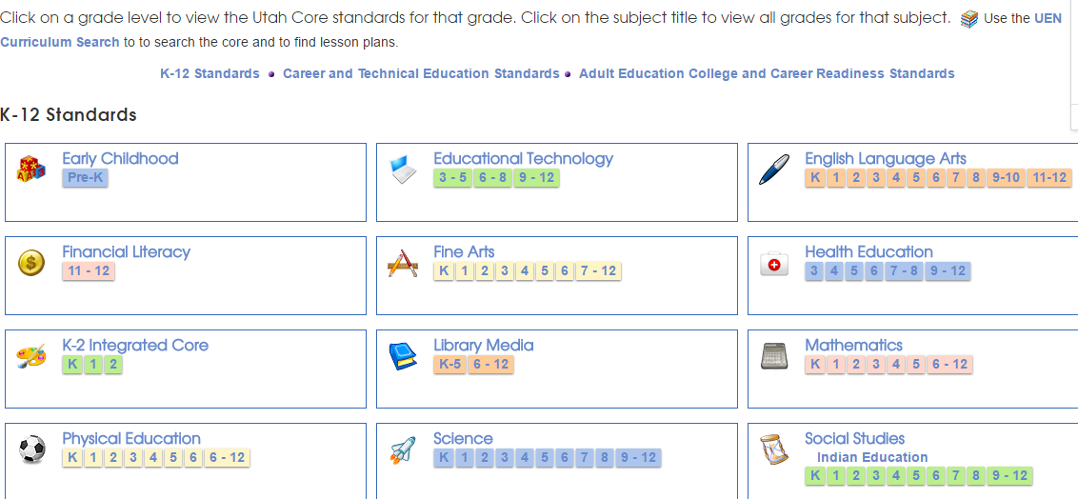

- Look at the rubrics page on Instructional Support Materials for many helpful tools for your subject area
http://www.schools.utah.gov/CURR/imc/Rubrics.aspx

For example for Math the rubric page helps you identify what skills students need to do to be proficient at that standard and the background knowledge they need for those tasks.

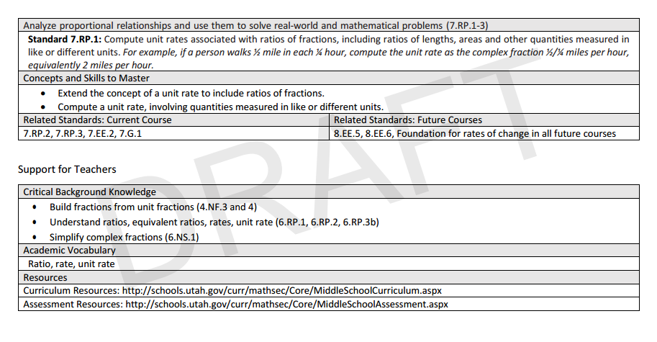

Step Two - Look at the standards and decide which ones are the most essential to get through first term. Contact your Department Head or Grade Level Team to see what work they have done to support you with this. It is still essential that you unpack the standards yourself to really understand what the students need to know and do to show proficiency of the content.

Why Unwrap the Common Core Standards?
Guaranteed and viable curriculum gives students access to the same essential learning regardless of who is teaching the class and each member of the team will work to ensure every student acquires the knowledge and skills the team has agreed are most essential for that unit." (Marzano, 2003)
“Unwrapped standards provide clarity as to what students must know and be able to do. When teachers take the time to analyze each standard and identify its essential concepts and skills, the result is more effective instructional planning, assessment and student learning.”
Question 1 – What do we want all students to learn?
Question 2 – How do we know if and when they’ve learned it?
Question 3 - How are we going to teach it?
Question 4 – How will we respond when some students don’t learn? How do we respond when some students have
already learned it?

Unpack the Core with the following steps so you understand what students need to do to be proficient at that skill:

Next, you will create a Learning Goal Scale so that you and your students can both be clear on what it is to be proficient in these standards. Next, you will develop activities and assessments that will help your students to show mastery of the standards. When we move to lesson planning design you will determine what is the learning target(s) of the lesson for each day and how is it meaningful and relevant beyond the specific task/activity.

Designing a Learning Goal Scale –Scales help the teacher and students know what proficiency is for that standard. The following chart shows the components of a Learning Goal Scale along.

Level | Type of Target | Description of Target
4.0 | Cognitively Complex Target | Target that reaches above the cognitive level of the standard that involves making in-depth inferences or applications
3.0 | Learning Goal Target(s) | Target that aligns with the cognitive level of the standard  Students will be able to:
2.0 | Foundational Target(s) | Target that builds to the standard (critical processes, necessary background information, essential vocabulary) underpinning the learning goal at cognitive levels below the standard  Students will recognize or recall specific vocabulary:  Student will be able to:
1.0 | With help, partial success at level 2.0 content and level 3.0 content  *Optional: If needed, prerequisite skills for 2.0 may be listed in 1.0.

- Level 1.0 remains the same with the option of including foundational prerequisites for 2.0.
- Scale may be developed with multiple standards that align instructionally.
- There should be a clear progression of thinking processes/performance skills from the foundational targets to the learning goal targets and above.

Develop a Tentative Calendar of Standards that all students are to LEARN that Quarter (You design your own that works for you. The following is just an example) :

Date ______  CSO  T  V | Date ______  CSO  T  V | Date ______  CSO  T  V | Date ______  CSO  T  V | Date ______  CSO  T  V
Date ______  CSO  T  V | Date ______  CSO  T  V | Date ______  CSO  T  V | Date ______  CSO  T  V | CSO – Content Standard and Objectives  EQ – Essential Question or Target  V - vocabulary

Step Three – Know your Students

- Find out what your students reading levels are, if they are in Special Education, ELL (English Language Learners), or have 504’s. You will be able to find some of this data in school city, on student profiles in the portal or ask school counselors, administrators, reading specialist, ELL coordinator, or Special Ed coordinator for this data. The following information will help you with the programs that can help you find student data. Mark names with a code on your seating chart or grade book so that you can remember. (Use a code you understand so that no one else sees this confidential information).

- School City Instructions: (You will learn to use this at Great Beginnings Training)
http://safari.graniteschools.org/SAFARI/generated/embedlinks/584ef781a17c1a93a27fa88b546fb225.mp4

and
http://safari.graniteschools.org/SAFARI/generated/embedlinks/cc2714a736c7477b7e8b7a6c1658889b.mp4

and Reports
http://safari.graniteschools.org/SAFARI/generated/embedlinks/d14dda3ee4ac2022e63152ba7ad85bbc.mp4


- Log on to the Portal – Go to District Resources – Go to Student Profile

Enter the Student Name and you will have access to Reading Scores (Dibels and SRI, SAGE, and Grades, Student phones numbers, if they are Special Ed, ELL and more.

- Once you have your data – determine a code system and mark students that are currently Special Education students, ELL or are below grade level in reading on your seating chart or in your gradebook, so that you can provide instruction to meet the needs of these students. (Use a code you understand so that no one else sees this confidential information).
- Work with your PLC to develop Common Formative Assessments to ensure students are learning the essential content.
- The teacher identifies the available materials that can enhance student understanding and the manner in which they will be used. Instructional materials have clear academic value in enhancing the students’ understanding of the content. Teacher is knowledgeable about ways that technology can support and enhance students’ learning including the use of computers, calculators, internet, video…
- The teacher collaborates with colleagues about student learning and instructional practices by seeking mentorship for areas of need or interest, and/or by mentoring other teachers through the sharing of ideas and strategies.
- Teacher engages in databased reflection with team and adjusts practice accordingly
How to Plan and Deliver Daily Lessons:
Domain I – Instruction and Assessment - Communication, Instructional Strategies, Engagement Strategies, Meaningful Learning, Individual Accommodations, Assessment Use, Long-Term Learning
Skills needed to be proficient in Domain I:
  - Delivers engaging and challenging lessons
  - Deepens and enrich students’ understanding through content area literacy strategies, verbalization of thought, and application of the subject matter
  - Identify gaps in student’s subject matter knowledge
  - Modify instruction to response to preconceptions or misconceptions
  - Relate and integrate the subject matter with other disciplines and life experiences
  - Employ higher order questioning techniques
  - Apply varied instructional strategies and resources, including appropriate technology to provide comprehensible instruction and to teach for student understanding
  - Differentiate instruction based on an assessment of student learning needs and recognition of individual. Differences in students.
Why Is Lesson Planning Important?
Many educators believe that lesson planning is a critical element of effective instruction. As an old adage says, “Failing to plan is planning to fail.” Lesson planning is also an opportunity to think about the kinds of teaching that result in student learning. Lesson planning helps ensure that classroom instruction aligns with curriculum goals and objectives and therefore enables students to demonstrate their successful learning on unit or curricular assessments. Lessons not only shape how and what students learn, they also impact student attitudes toward language learning. In the long run, it is the lesson—not the curriculum or the unit plan—that students actually experience. It is through the lessons they teach each day that teachers communicate what learning is all about and what they believe matters in learning. As they experience the lesson, students may decide whether they will or will not invest their time and energy to learn the material.

The teacher must first think about two things: (1) what will students be able to do at the end of the lesson and more importantly at the end of each learning episode within the lesson, and (2) what must they know in order to do that? Since lessons occur within a unit context, everything the teacher includes in the lesson plan is housed under the umbrella of the unit’s theme, learning targets, and knowledge base. This means that the learning targets for a particular lesson can come directly from the unit plan or may need to be “unpacked” to include a number of subtargets that are in service to a bigger, more inclusive target. However the teacher arrives at the focus of the lesson, the target(s) should be attainable within the scope of the lesson’s available time, and they should be stated in student-friendly language. Learning targets that speak to the needs and interests of students are more likely to capture their energy and commitment.
Things to think about before planning the lesson:
- Give students a reason for needing to or wanting to pay attention and be on-task
- Provide students with an authentic (real world) purpose for using language
- Make the learner—not the teacher—the active participant
- Engage all students as opposed to just one or two at a time
- Provide sufficient opportunities for input before expecting output
- Provide multiple, varied opportunities for students to hear new words and expressions in highly visualized contexts that make meaning transparent
- Represent the best use of instructional time
- Take an appropriate amount of time considering the age of the learner
- Include enough variety to enable a lively pace for the lesson
- Vary in the level of intensity and physical movement from one to the next

NOTES:

WEBB’S DEPTH OF KNOWLEDGE OVERVIEW

Webb (1997) developed a process and criteria for systematically analyzing the alignment between standards and standardized assessments. Since then the process and criteria have demonstrated application to reviewing curricular alignment as well. This body of work offers the Depth of Knowledge (DOK) model employed to analyze the cognitive expectation demanded by standards, curricular activities and assessment tasks (Webb, 1997). The model is based upon the assumption that curricular elements may all be categorized based upon the cognitive demands required to produce an acceptable response. Each grouping of tasks reflects a different level of cognitive expectation, or depth of knowledge, required to complete the task. It should be noted that the term knowledge, as it is used here, is intended to broadly encompass all forms of knowledge (i.e. procedural. declarative, etc.). The following table reflects an adapted version of the model.

DOK Level | Title of Level
1 | Recall and Reproduction
2 | Skills and Concepts
3 | Short-term Strategic Thinking
4 | Extended Thinking

DOK levels are assigned to each course objective. The following served as general guidelines for developers:

- The DOK level assigned should reflect the level of work students are most commonly required to perform in order for the response to be deemed acceptable.
- The DOK level should reflect the complexity of the cognitive processes demanded by the task outlined by the objective, rather than its difficulty. Ultimately the DOK level describes the kind of thinking required by a task, not whether or not the task is “difficult”.
- If there is a question regarding which of two levels a statement addresses, such as Level 1 or Level 2, or Level 2 or Level 3, it is appropriate to select the higher of the two levels.
- The DOK level should be assigned based upon the cognitive demands required by the central performance described in the objective.
- The objective's central verb(s) alone is/are not sufficient information to assign a DOK level. Developers must also consider the complexity of the task and/or information, conventional levels of prior knowledge for students at the grade level, and the mental processes used to satisfy the requirements set forth in the objective

Curricular elements that fall into this category involve basic tasks that require students to recall or reproduce knowledge and/or skills. The subject matter content at this particular level usually involves working with facts, terms and/or properties of objects. It may also involve use of simple procedures and/or formulas. There is little transformation or extended processing of the target knowledge required by the tasks that fall into this category. Key words that often denote this particular level include: list, identify and define. A student answering a Level 1 item either knows the answer or does not; that is, the answer does not need to be "figured out" or "solved."

POSSIBLE PRODUCTS

Quiz | List | Collection | Podcast | Social Bookmarking
Definition | Workbook | Explanation | Categorizing/Tagging | Searching
Fact | Reproduction | Show and Tell | Commenting | Googling
Worksheet | Vocabulary Quiz | Outline | Bulleting
Test | Recitation | Blog | Highlighting
Label | Example | Wiki | Social Networking

ROLES
Teacher |  | Student
Directs | Tells | Responds | Absorbs
Shows | Examines | Remembers | Recognizes
Questions | Evaluates | Memorizes | Describes
Demonstrates | Listens | Explains | Translates
Compares | Contrasts | Restates | Demonstrates
Examines |  | Interprets

POTENTIAL ACTIVITIES

- Develop a concept map showing a process or describing a topic.
- Make a timeline.
- Write a list of keywords you know about...
- Make a chart showing…
- Recite a fact related to...
- Write in your own words...
- Cut out, or draw a picture that illustrates an event, process, or story.
- Report or present to the class.
- Make a cartoon strip showing the sequence of an event, process, or story.
- Write and perform...
- Write a brief outline and explain the event, process, or story.
- Write a summary report of the event.
- Prepare a flow chart that illustrates the sequence of events.
- Paraphrase a chapter in the book.
- Retell in your own words.
- Outline the main points.
- Recall, restate, remember, or recognize a fact, term, or property (recognizing, listing, describing, identifying, retrieving, naming, locating, finding).

LEVEL 2 – WORKING WITH SKILLS & CONCEPTS

Level 2 includes the engagement of some mental processing beyond recalling or reproducing a response .This level generally requires students to contrast or compare people, places, events and concepts; convert information from one form to another; classify or sort items into meaningful categories; describe or explain issues and problems, patterns, cause and effect, significance or impact, relationships, points of view or processes. A Level 2 “describe or explain" would require students to go beyond a description or explanation of recalled information to describe or explain a result or "how" or "why." The learner should make use of information in a contest different from the one in which it was learned.

Elements found in a curriculum that fall in this category involve working with or applying skills and/ or concepts to tasks related to the field of study in a laboratory setting. The subject matter content at this particular level usually involves working with a set of principles, categories, heuristics, and protocols. At this level students are asked to transform/process target knowledge before responding. Example mental processes that often denote this particular level include: summarize, estimate, organize, clarify, and infer.

POSSIBLE PRODUCTS

Photograph | Presentation | Reverse-Engineering | Blog Commenting
Illustration | Interview | Cracking Codes | Blog Reflecting
Simulation | Performance | Linking | Moderating
Sculpture | Dairy | Mashing | Testing (Alpha/ Beta)
Demonstration | Journal | Relationship Mind Maps | Validating

ROLES

Teacher |  | Student
Shows | Facilitates | Solves problems | Demonstrates use of knowledge
Observes | Evaluates | Calculate s | Compiles
Organizes | Questions | Completes | Illustrates
 |  | Constructs

POTENTIAL ACTIVITIES

- Classify a series of steps
- Construct a model to demonstrate how it looks or works
- Practice a play and perform in class
- Make a diorama to illustrate an event
- Write a diary/blog entry
- Make a scrapbook about the area of study
- Make a topographic map
- Make up puzzle or game about the topic
- Write an explanation about this topic for others
- Make a model…
- Routine application tasks [i.e. applying a simple set of rules or protocols to a laboratory situation the same way each time)
- Explaining the meaning of a concept and/or explaining how to perform a particular task
- Stating relationships among a number of concepts and or principles

LEVEL 3—SHORT-TERM STRATEGIC THINKING

Items falling into this category demand a short-term use of higher order thinking processes, such as analysis and evaluation, to solve real-world problems with predictable outcomes. Stating one's reasoning is a key marker of tasks that fall into this particular category. The expectation established for tasks at this level tends to require coordination of knowledge and skill from multiple subject-matter areas to carry out processes and reach a solution in a project-based setting. Key processes that often denote this particular level include: analyze, explain and support with evidence, generalize, and create.

POSSIBLE PRODUCTS

Graph | Survey | Debate | Conclusion | Podcast
Spreadsheet | Database | Panel | Program | Publishing
Checklist | Mobile | Report | Film | Wiki-ing
Chart | Abstract | Evaluating | Animation
Outline | Report | Investigation | Video Cast

ROLES

Teacher |  | Student
Probes | Guides | Discusses | Uncovers | Argues
Observes | Evaluates | Debates | Thinks deeply | Tests
Acts as a resource | Questions | Examines | Questions | Calculates
Organizes | Dissects | Judges | Disputes | Compares
Clarifies | Accepts | Assesses | Decides | Selects
Guides |  | Justifies

POTENTIAL ACTIVITIES

- Use a Venn Diagram that shows how two topics are the same and different
- Design a questionnaire to gather information
- Survey classmates/industry members to find out what they think about a particular topic
- Make a flow chart to show the critical stages.
- Classify the actions of the characters in book
- Prepare a report about an area of study
- Conduct an investigation to produce information to support a view
- Write a letter to the editor after evaluation product
- Prepare and conduct a debate
- Prepare a list of criteria to judge
- Writ e a persuasive speech arguing for/against...
- Make a booklet about five rules you see as important. Convince others.
- Form a panel to discuss viewpoints on...
- Write a letter to …. advertising on changes needed.
- Prepare a case to present your view about
- Short-term tasks and projects placing a strong emphasis on transferring knowledge to solve predictable problems
- Explaining and/or working with abstract terms and concepts
LEVEL 4 – EXTENDED STRATEGIC THINKING

Curricular elements assigned to this level demand extended use of higher order thinking processes such as synthesis, reflection, assessment and adjustment of plans over time. Students are engaged in conducting investigations to solve real-world problems with unpredictable outcomes. Employing and sustaining strategic thinking processes over a longer period of time to solve the problem is a key feature of curricular objectives that are assigned to this level. Key strategic thinking processes that denote this particular level include: synthesize, reflect, conduct, and manage.

POSSIBLE PRODUCTS

Film | Project | New Game | Newspaper
Story | Plan | Song | Media Product

ROLES

Teacher |  | Student
Facilitates | Extends | Designs | Formulates | Plans
Reflects | Analyzes | Takes Risks | Modifies | Creates
Evaluates |  | Proposes

POTENTIAL ACTIVITIES

- Applying information to solve ill-defined problems in novel situations
- Tasks that require a number of cognitive and physical skills in order to complete
- Writing and/or research tasks that involve formulating and testing hypotheses over time
- Tasks that require students to make multiple strategic and procedural decisions as they are presented with new information throughout the course of the event
- Tasks that require perspective taking and collaboration with a group of individuals
- Creating graphs, tables, and charts where students must reason through and organize the information without instructor prompts
- Writing tasks that have a strong emphasis on persuasion
- Devise a way to...
- Develop a menu for a new restaurant using a variety of healthy foods
- Sell an idea
- Write a jingle to advertise a new product
- Conduct an internship in industry where students are faced with real-world, unpredictable problems

Assessment ideas
http://www.formativedifferentiated.com/handouts.html

