Anchor Standards for Reading

Read
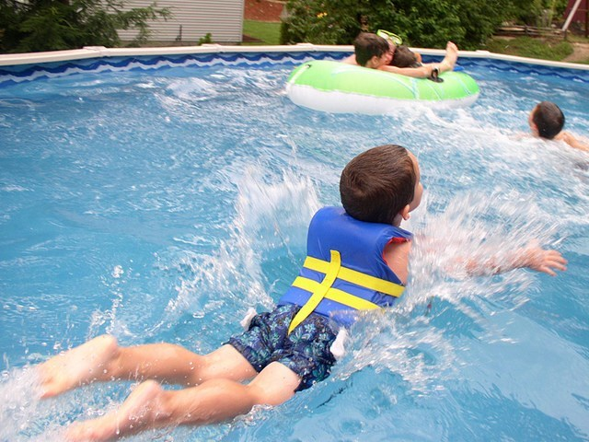
RL & RI Standards 1-3, DOK 1-2
Identify Key Ideas & Details
Focus: What does the text Say? Take notes, retell, summarize
Reread
Skimming the Surface
RL & RI Standards 4-6, DOK 2-3

Analyze Craft & Structure Focus: How does the text work? What does the author mean? Figurative & Connotative Phrases Author Questions
Under the Water
Integrate
RL & RI Standards 7-9, DOK 3-4
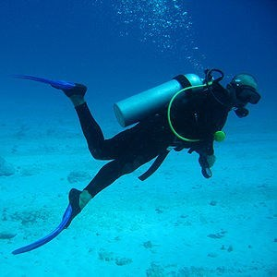
Integration of Knowledge & Ideas
Focus: What is the text's value?
How does the text connect to other information? Make Text Connections
Scuba Diving

